Strayer University

**uGrade**

Week 10

**Assignment 2**

for

the

Course of

### Java programming 1

.12/11/17

By

Kennedy Kabaso.

Professor: Stone Mark.

**UGrade.**

This assignment was about the new interactive learning management tool called uGrade. The program will sort the names and grades of students in two parallel arrays. It would allow the user to manually enter names and grades. Then would store this information in parallel arrays as mentioned already. Next, it will prompt the user to select the sorting criteria either by name or by grade and display the sorted data accordingly in an organized table. This means data entry at position i in both array belongs to each other.

Below are two arrays and two valuables which are used in the Program.

* + String[] lastName = new String[5];
  + int[] grades = new int[5];
    - int grades;
    - String lastName;

Then the user can enter the information which will be prompted by the following, System.out.print("Enter student grade >>"); which put the input into the following the parallel arrays: grade = input.nextInt(). Then the same steps are done for the rest of the following;

* System.out.print("Enter student ’s Last name >>");
  + lastName = input.nextLine();

The data will be stored in the above variables. The following bubble sort method will be computed,

* BubbleSort(lastName, grades );

When the program runs, it prompts the user to enter the five students last name and their grade Then it will computer the sorting method which is bubble. In addition, the user will be prompting to select a sorting criterion or to end the program. This can be done by either select **name or grade** as the sorting criteria. After everything is done, the results will be display at the end of the program after doing the computation which is based on the instruction which are in the method of the programs. The process continue until the user ends the program and the output is displayed in the screen shot below.

**Section 2:  Screen Shot of the Output and Description of Your Java Program**

* The screen shot for the output for the user who chose to sort by name:

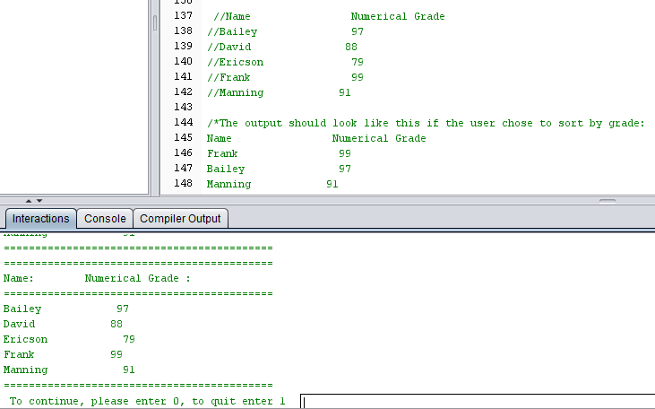

* The screen shot for the output for the user who chose to sort by grades:

